**GSA,** WGIC sign cooperation agreement

***Published:***

*11 October 2019*

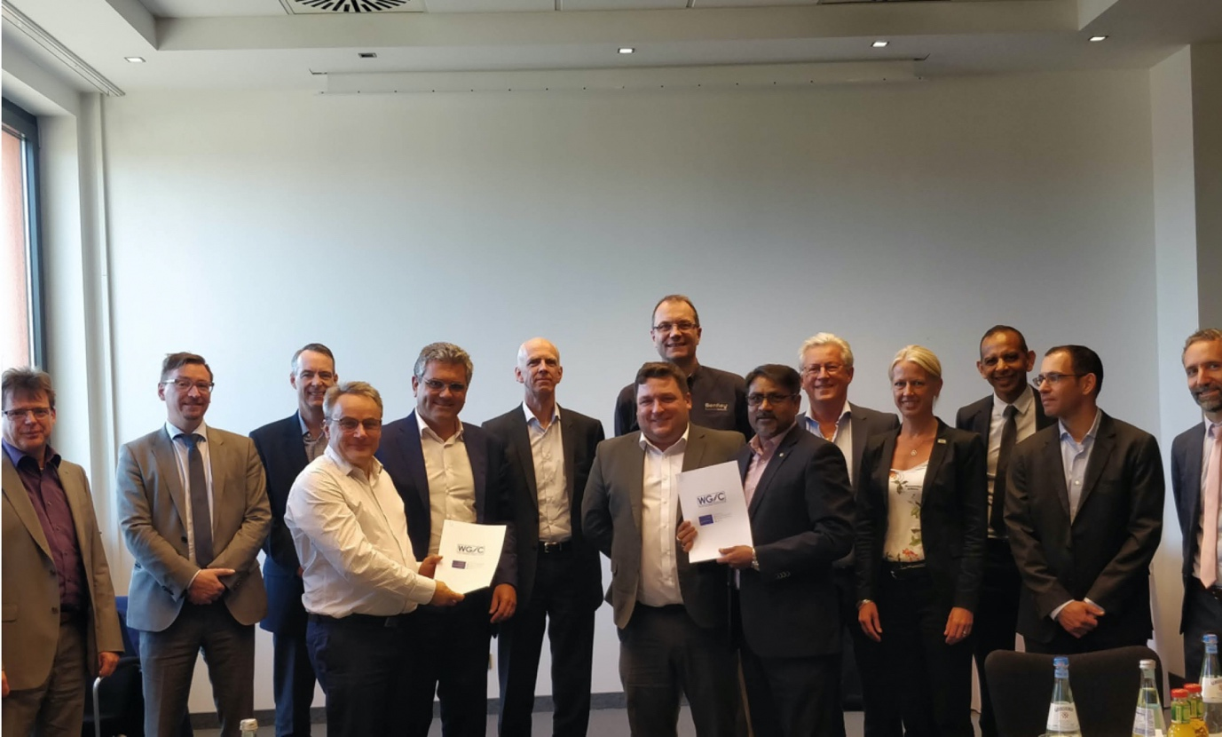

*The GSA-WGIC agreement will increase the joint contribution of geospatial and satellite navigation technology to a wide range of projects.*

**The European GNSS Agency (GSA) and the World Geospatial Industry Council (WGIC) have signed a memorandum covering cooperation to promote the combined use of geospatial technology and European satellite navigation systems, to jointly contribute to projects across a wide range of activities, from sustainable development and achieving global development agendas, including the SDGs, to innovative opportunities that benefit citizens and enterprises.**

“The benefits of global navigation satellite systems (GNSS) are everywhere. GNSS plays a critical role in driving innovations for future economic growth, sustainability for businesses as well as public services,” said GSA Chief Operating Officer Pascal Claudel at the signing ceremony, which was held in Stuttgart, Germany on 19 September.

**Instrumental association**

Claudel noted that space is a tangible service that addresses the need for apps among growing smartphones user communities, navigation systems for smart transport, accuracy for position, timing for flight landings, and much more. “This association with WGIC will be instrumental in leveraging the collective technical capabilities of geospatial information and space technology across different sectors, professional services and applications,” he said.

**Read this**: [GSA, EIB sign agreement on investment in space](https://www.gsa.europa.eu/newsroom/news/gsa-eib-sign-agreement-investment-space)

“GNSS and positioning technologies enable positional accuracy, time and precision for strategic insights, using geospatial information for location based services, smart transportation, mapping and surveying, facilitating development of innovative applications across various sectors of the economy,” said WGIC Secretary General and CEO Sanjay Kumar.

“WGIC, with its member network from the entire ecosystem of the industry, is the single largest industry association worldwide to bring together all the stakeholders and partners to work in tandem towards successfully leveraging the potential of such technology collaborations,” he said.

**New dialogue paradigms**

This association between the GSA and WGIC will create new paradigms for dialogue on harnessing GNSS and geospatial technical capabilities. Both organisations will work closely to develop joint programmes and facilitate strategic dialogue to encourage the wider adoption of geospatial and GNSS capabilities for commercial as well as public institutions, towards the ultimate goal of achieving greater public good.